Samuel Harkness
PHYS-211
Lab Report on Motion

In this experiment we studied how the concepts of position, velocity, and acceleration are used to describe linear motion. Sonic motion detectors and computers were used to graphically display the position, velocity, and acceleration of objects in motion.
In kinematics, the equations of motion are four equations that apply to bodies moving in one dimension with uniform acceleration. Often, problems in kinematics deal with more than two variables, and several applications of the equations are required.
V_{f} = v_{i} + aΔt
Δx = ½( v_{i} + v_{f} )Δt
Δx = v_{i}Δt + ½aΔt²
v_{f} ² = v_{i}² + 2aΔx
where v_{i} is the initial velocity, V_{f} is the final velocity, Δx is the difference between the initial position and the final position, a is the constant acceleration, and Δt is the difference in time. Note that each of the equations contains four of the five variables. When using the above formulas, it is sufficient to know three out of the five variable to calculate the remaining two.
The motion detector used in the experiment uses echolocation to measure the distance to an object. The detector, which is aimed towards the object, emits a 'click' and listens for the echo as the sound wave bounces off the surface of the object and returns to the detector. From the elapsed time, the computer calculates the distance to the object. With this information, the computer also calculates velocities and accelerations.
We investigated the relationships between velocity and acceleration with a ball rolling on an inclined ramp. A motion detector was positioned at the bottom of the ramp as shown in the figure below.
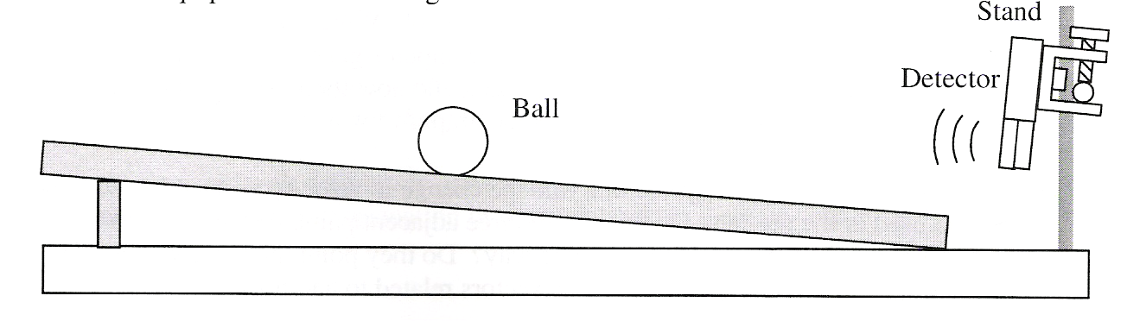
Giving the ball a push up the ramp and then letting gravity roll it back down the ramp produced graphs as shown below, where the horizontal axis is time. The graphs show that the position of the ball can be defined as a quadratic equation, the velocity as a linear equation, and the acceleration as a constant.
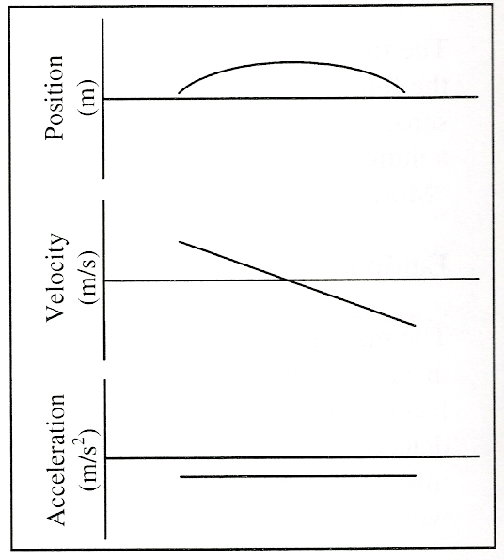
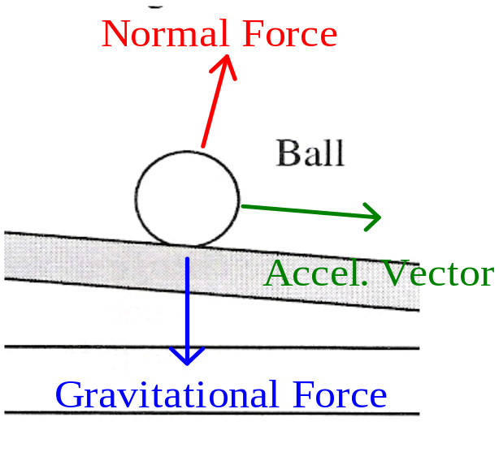
According to the graph, the acceleration is negative, but is not the gravitational constant of 9.80 m/s². This is because the ramp pushes back against the ball perpendicular to the plane of the ramp, as shown by the red arrow in the figure above. This is called the normal force. Taking the difference between the normal force and the gravitational force gives us the acceleration vector, which points down the ramp with a slope parallel to the ramp. This accounts for the acceleration being less than 9.80 m/s². This force is always working on the ball, even when it rolls up the ramp, causing it to lose velocity.
Looking at the graph for velocity, we can see that it starts with a high velocity, provided by the push up the ramp. Gradually, the ball loses velocity and comes to a rest, at which point the graph crosses the horizontal axis. After the turn-around point, the ball begins to gain speed once again, though this time it is directed down the ramp, therefore the negative velocity.
For the position graph we can tell that the ball quickly distances itself from the motion detector. Gradually the graph begins to flatten out as the ball loses velocity and does not distance itself as fast from the motion detector. The graph reaches it's apex at the same time the ball stops, and then the ball begins it's return to the motion detector.

